Building the Greenplum Database 4.3.4.0 Sandbox Environment

This document provides information necessary to create the Greenplum Database sandbox environment.

This environment supports the Greenplum Architecture, Administration, and Implementation Lab exercises inherited from EMC. This environment is built on GPDB version 4.3.4.0.

This environment consists of 4 Centos 6.5 Virtual Machines that are created using the ‘vagrant’ application. The 4 vm’s are:

1. GPDB Master ( mdw ) – 4gb of Memory
2. GPDB Standby Master ( smdw ) – 1gb of Memory
3. Segment 1 ( sdw1 ) – 1gb of Memory
4. Segment 2 ( sdw2 ) – 1gb of Memory

The vagrant build environment consists of:

1. Vagrantfile – instructions for vagrant to build the 4 vm’s
2. A series of shell scripts that are called during the build process
3. VM-Bits – directory containing all of the artifacts required for building the environment. These artifacts include binaries, zip files and data

The ‘vagrant’ build environment can be found at:

<https://github.com/pivotal-education/greenplum-4-3-4-0.git>

Steps to build the GPDB 4.3.4.0 Sandbox environment

1. Install the latest version of vagrant. The download can be found at:  
   <https://www.vagrantup.com/downloads.html>
2. Install the latest version of VirtualBox. The download can be found at:  
   <https://www.virtualbox.org/wiki/Downloads>
3. Access the ‘greenplum-4-3-4-0’ repository at:  
   <https://github.com/pivotal-education/greenplum-4-3-4-0.git>
   1. Select the ‘Download ZIP’ button.
   2. There should be a directory called ‘greenplum-4-3-4-0-master’ downloaded to your computer.
   3. Move ‘greenplum-4-3-4-0-master’ to the Desktop of your computer
4. Fetch ‘VM-Bits for 4-3-4-0.7z’ from Amazon S3 using the following command:  
   blah blah blah blah
5. Unzip ‘VM-Bits for 4-3-4-0.7z’ as ‘VM-Bits’ into the directory ‘greenplum-4-3-4-0-master’.
   1. The contents of the ‘greenplum-4-3-4-0-master’ directory should resemble: 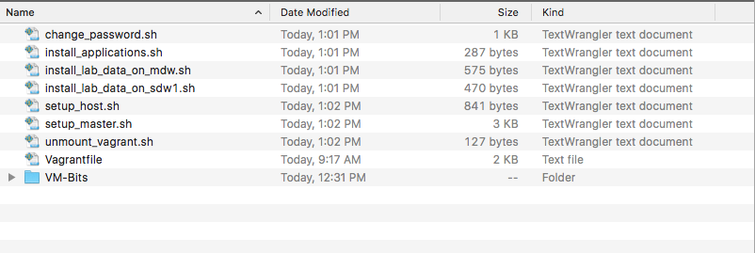
6. Open a terminal window and change to ‘greenplum-4-3-4-0-master’ directory.
   1. From the command line run the command ‘vagrant up’.
   2. Be patient!! The build will take 4 to 5 minutes.
7. Launch VirtualBox. The 4 vm’s should have been created successfully and in the ‘running’ state.
8. Test the connectivity to the vm’s.
   1. Launch a terminal window and ssh to 172.16.1.11 ( mdw ). The password is ‘Piv0tal’ for all of the vm’s.
   2. Once you have verified connectivity exit the ssh session and login to each of the remaining vm’s. Their IP addresses are:
      1. 172.16.1.14 – smdw
      2. 172.16.1.12 – sdw1
      3. 172.16.1.13 – sdw2
9. Select the first vm in the list in the VirtualBox dashboard. Note that it indicates that there is 1 Shared Folder associated with this vm. 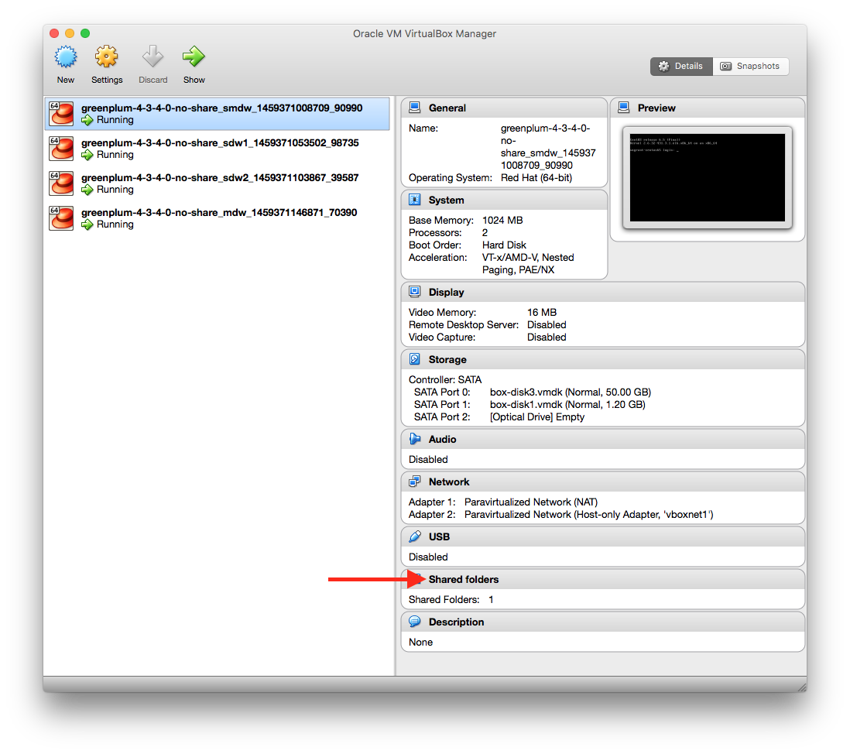
   1. Select ‘Shared Folders’, select the name of the share and delete the share by selecting the delete icon.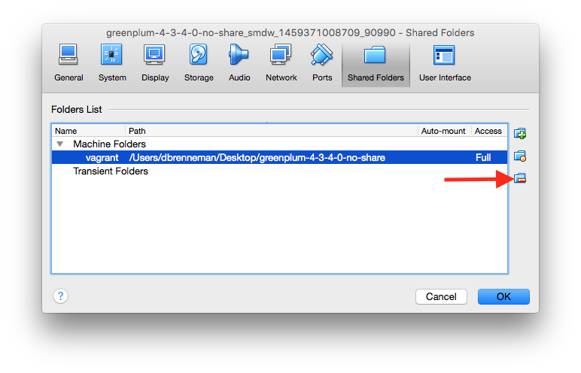
   2. Delete the Shares from each of the three ( 3 ) remaining vm’s
10. Locate the ‘VirtualBox VMs’ directory at the root level on your computer and zip the directory. Be patient as it may take a while depending on the chosen compression level .
11. You may now distribute this zip file or push it back to Amazon S3.